**REACT COURSE**

**T Sree Sowmya**

**221910304044**

**Gitam Hyd CSE**

**DAY-4 6/12/2022**

**By Variable:**

import logo from './logo.svg';

import './App.css';

import Gitam from './Gitam';

function App() {

  let item="UNIVERSITY";

  function Data()

  {

    item="Sowmya ,B Tech ";

    alert(item);

  }

  return (

    <div className="App">

    <h1>{item}-original data </h1>

    <button onClick={Data}>Submit </button>

    </div>

  );

}

export default App;

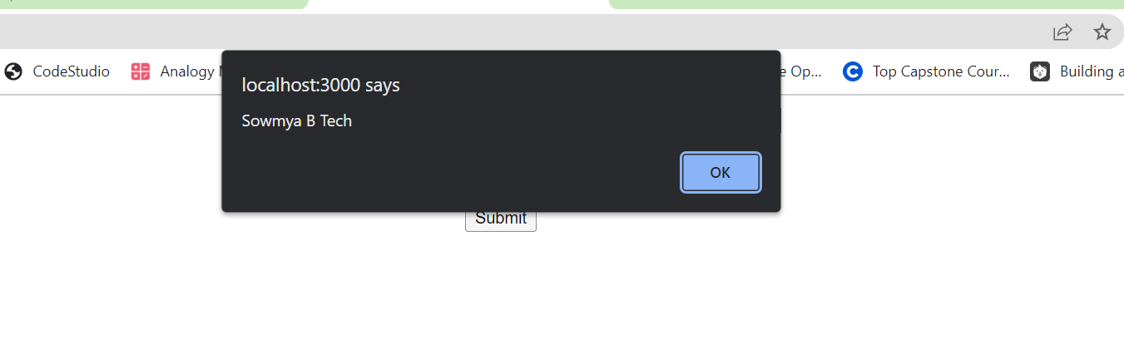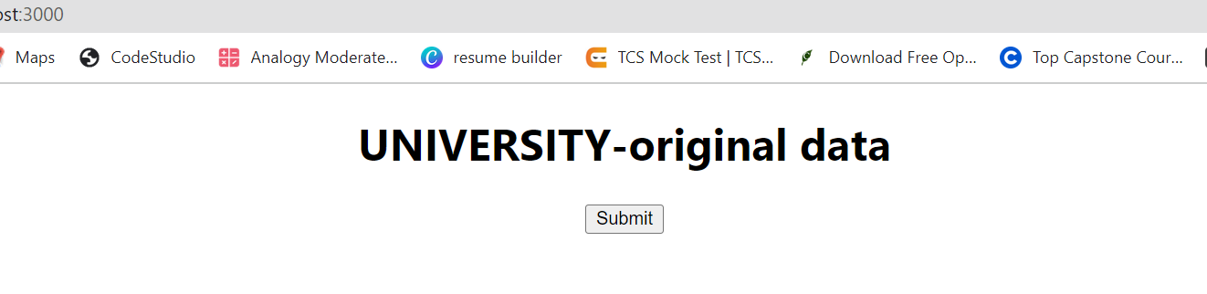

**State:**

A state is a data container same like as variable, whenever the value of state is changed immediate effect will be there.

Program:

1. To demonstrate the concept of state ,by using functional component,

Syntax:

const(Data,setData)=useData(“abc”);

Name of updating to new initialize the start value

The variable value

**Program which explains the concept of using State in Functional Component**

Should “import {useState} from 'react'”

import logo from './logo.svg';

import './App.css';

import {useState} from 'react';

import Gitam from './Gitam';

function App() {

  //let item="UNIVERSITY";

  const[data,setData]=useState("Sowmya");

  function Updatedata()

  {

    setData("T Sree Sowmya B Tech");

    //alert(setData);

  }

  return (

    <div className="App">

    <h1>{data}</h1>

    <button onClick={Updatedata}>Click </button>

    </div>

  );

}

export default App;

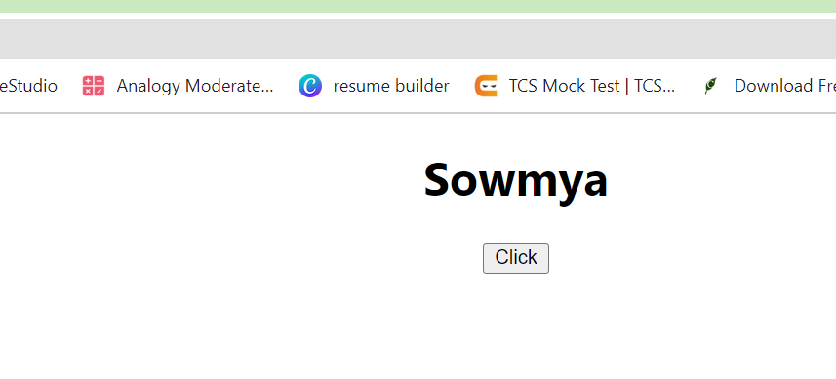

After clicking on the button the updated statement is T sree Sowmya B tech

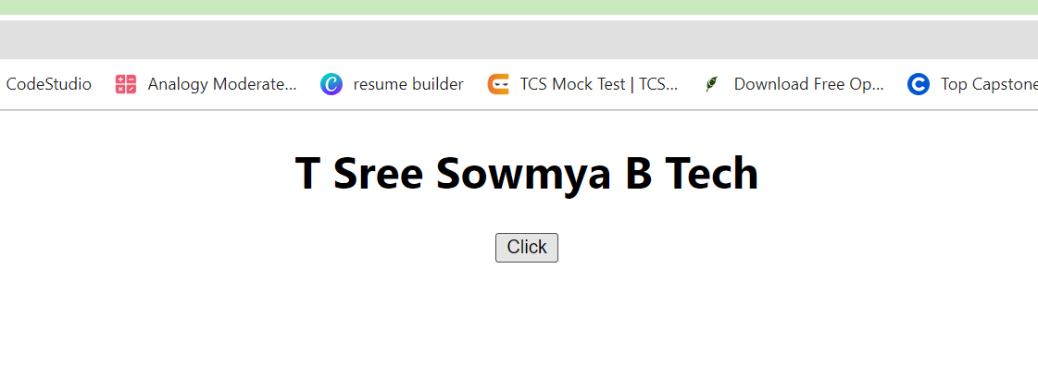

**States in Class component:**

Declaration of variable is done in constructor. Declaration of variable with related to state and class component can be return as

This.data={

Data=1

}

This.state={

Data=1

}

**Program which explains the concept of using State in Class Component**

import logo from './logo.svg';

import './App.css';

import {useState} from 'react';

import Gitam from './Gitam';

import React,{Component} from 'react'

class App extends Component

{

constructor()

{

super();

this.state={

data:24

}

}

 Apple()

{

this.setState({data:this.state.data+20})

}

render()

{

return (

<div className="App">

<h1>{this.state.data}</h1>

<button onClick={()=>this.Apple()}>Update Data</button>

</div>

)

}

}

export default App;

ORIGINAL VALUE:

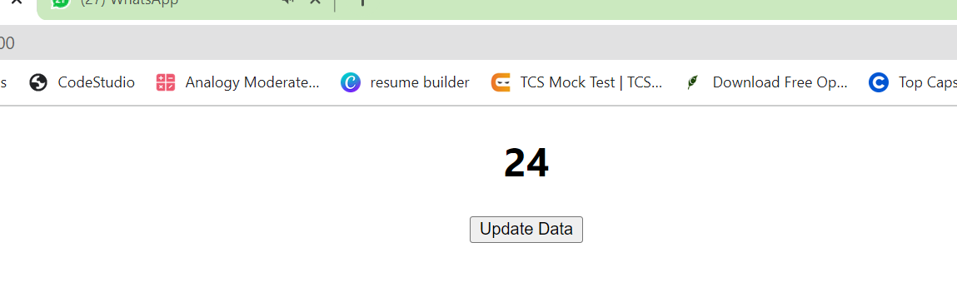

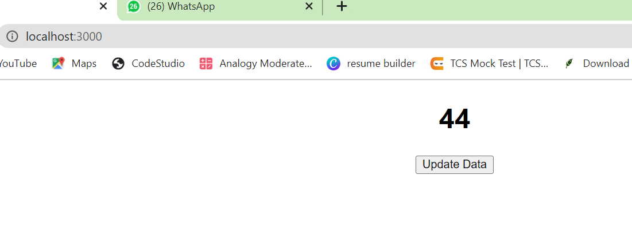44 IS UPDATED VALUE ,WHEN CLICKED ON BUTTON

ASSIGNMENT-2:

Q1. Declare a variable called GITAM and initially pass the value as your "name" to GITAM .declare a function called Assignment2 in App function.

In that Assignment2 function,update the value of GITAM to Assignment3 . In function App ,display the value of GITAM and create a Button called

"YourName_Assignment". When that button is clicked , it needs to display the Assignment3 and updated value of GITAM(by using state

in Functional Component).